Sharp Streaks Architecture Documentation
This document outlines the technical architecture of the Sharp Streaks application, including data models, relationships, and user flows.
Entity Relationship Diagram (ERD)
The ERD illustrates the core database tables and their relationships within the system.
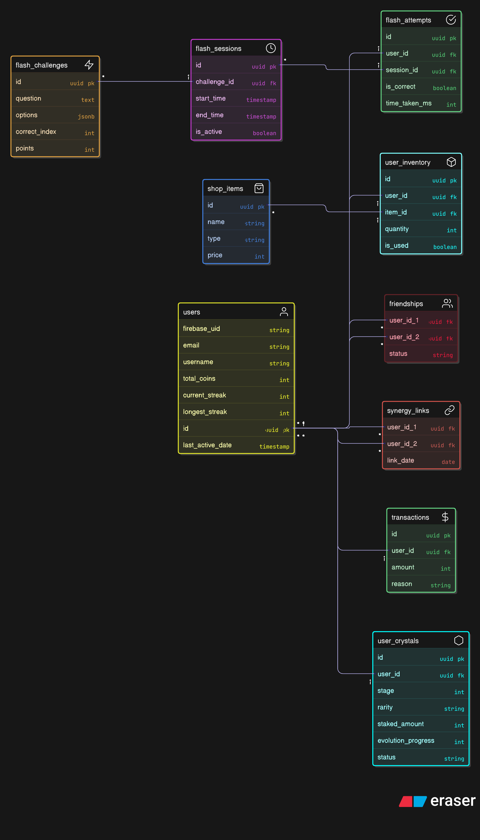
Data Relationship Diagram (DRD)
The DRD focuses on how data flows between high-level components during key operations.
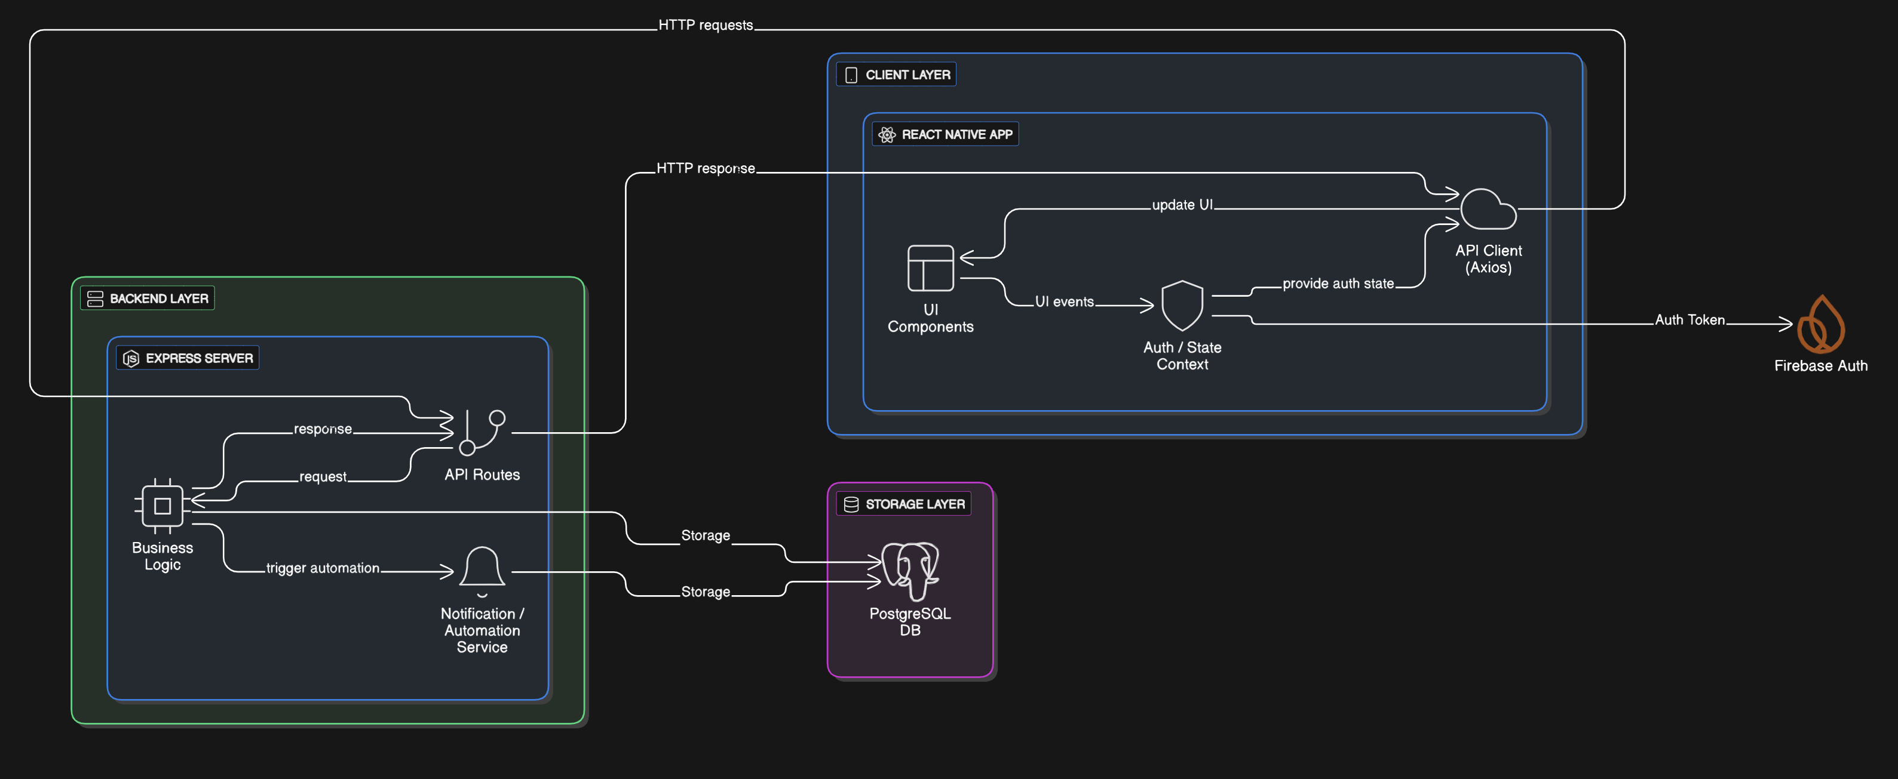
User Journey / Flow
1. Daily Engagement Flow
How a user interacts with the app on a daily basis to maintain streaks.
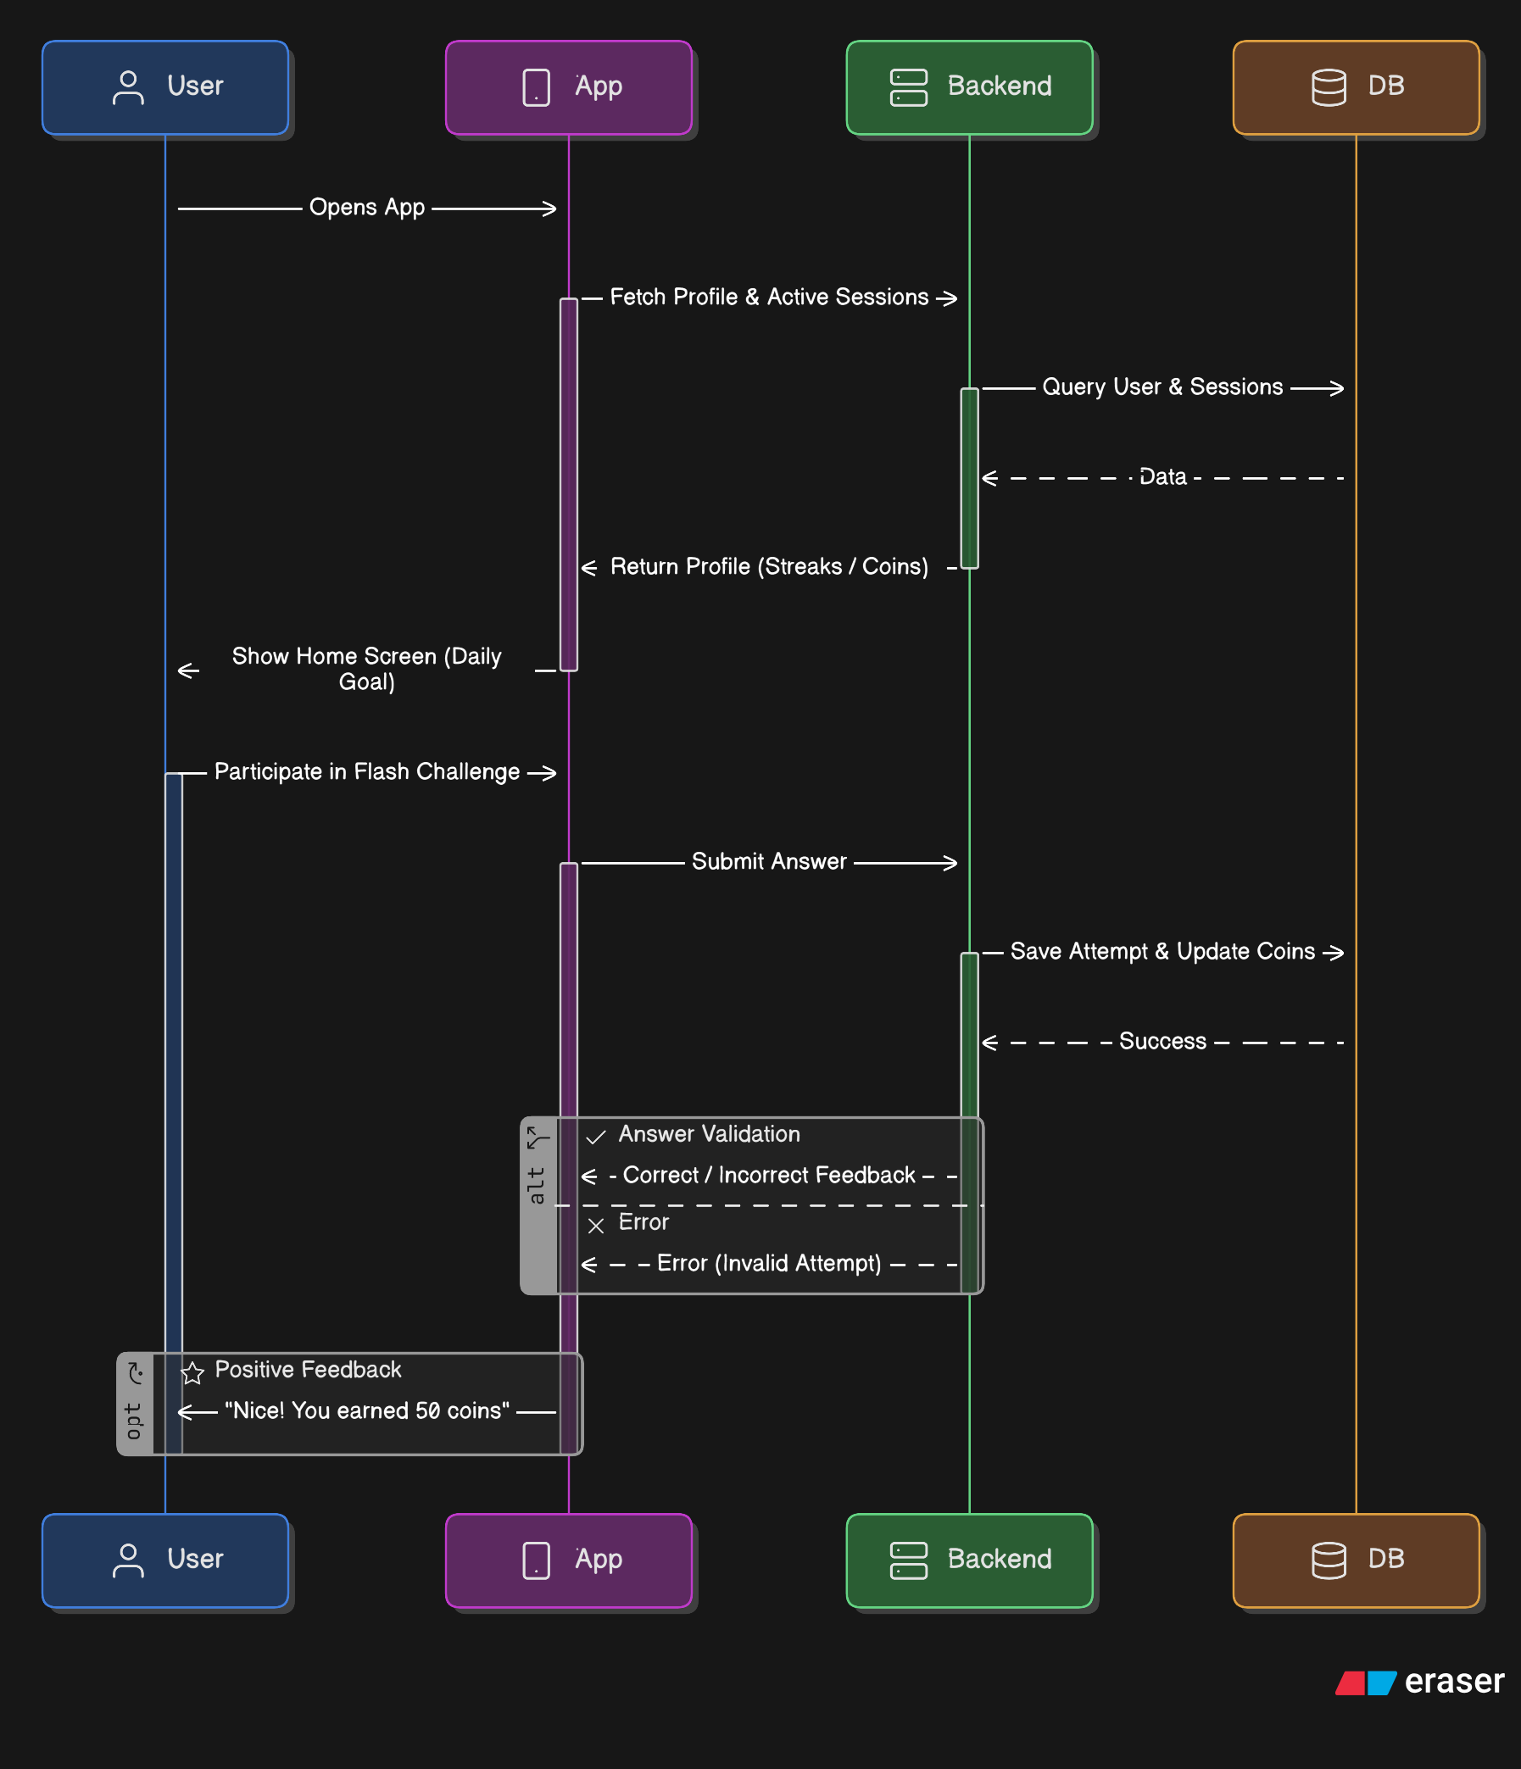
2. Crystal Forge Journey
The gamified evolution path within the app.
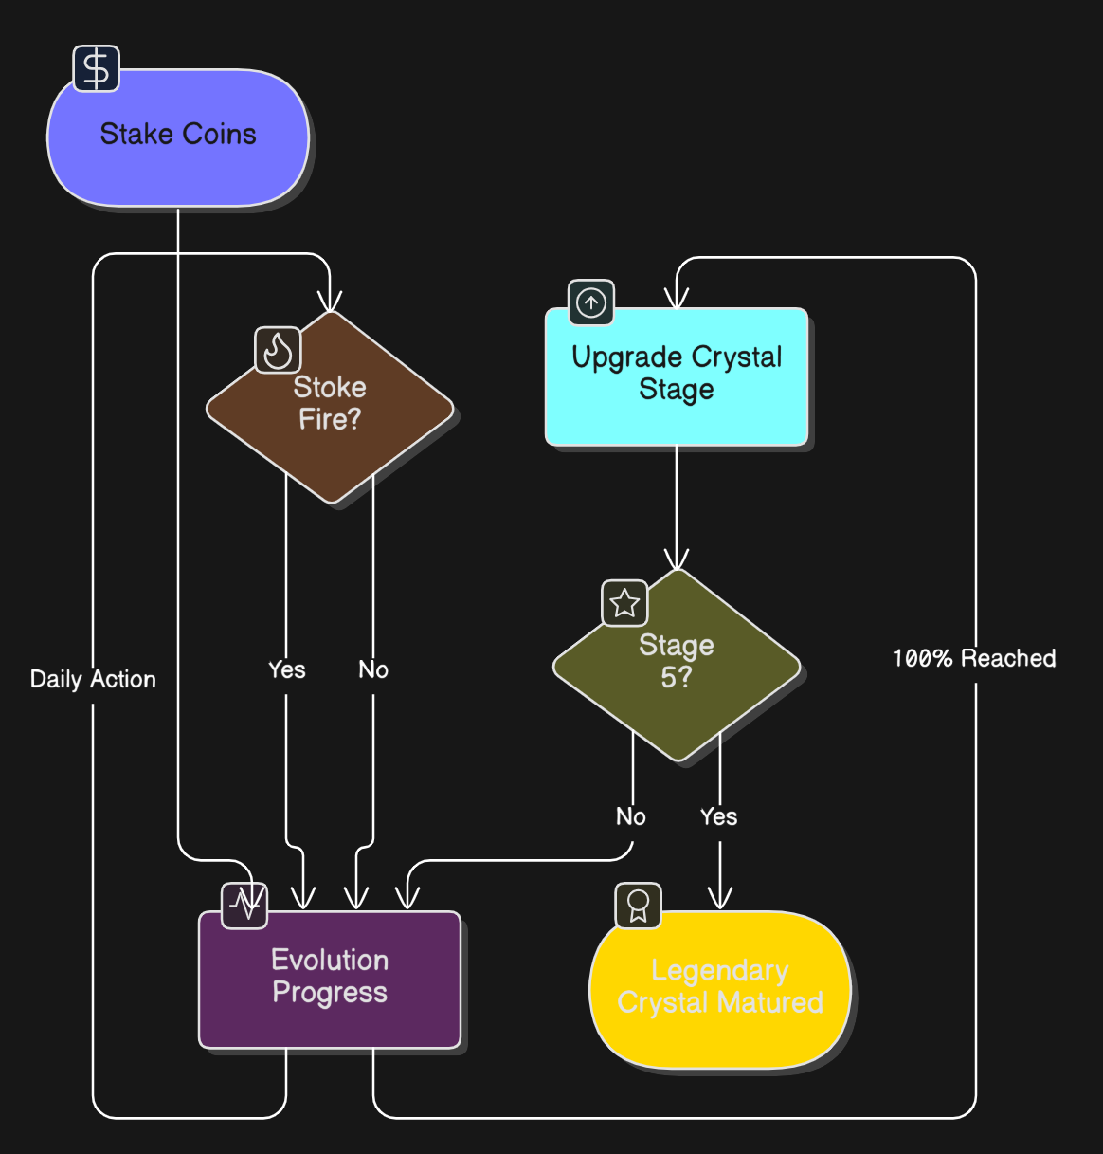
Technical Trade-offs
- PostgreSQL JSONB: Used for flash_challenges options to allow flexible question formats without complex join tables.
- Firebase Auth + Local DB: Firebase handles secure login, while PostgreSQL stores game state (coins, crystals) for high-performance querying and leaderboards.
- UUIDs: All IDs are UUIDs to ensure secure, non-sequential resource identifiers across distributed clients.

